FH456-- How to setup AP mode
Note: This article will guide you how to setup AP mode and the steps as below.

Step 1: Connect your computer to the LAN port. Power on the FH456.
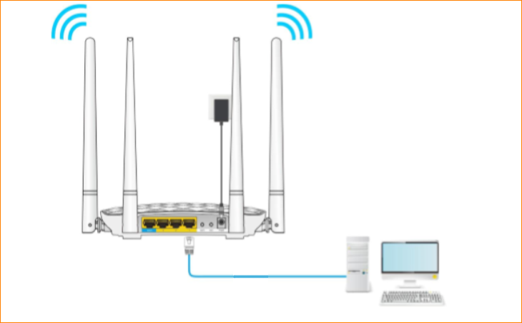
You can also use your smartphone to configure the router.
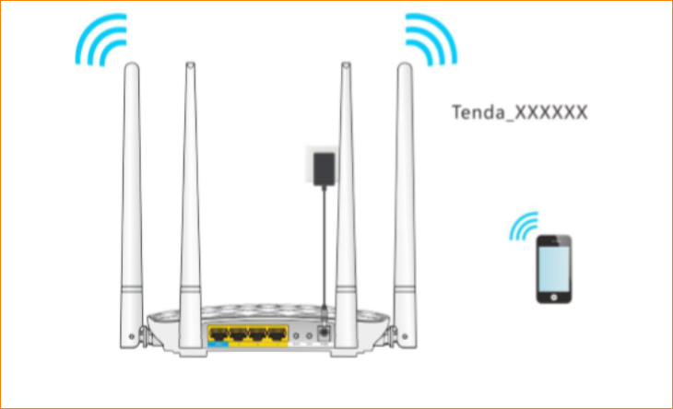
Step 2: Open a Web Browser -> Type http://tendawifi.com or 192.168.0.1 in the address bar -> Press Enter
Step 3: Go to Wireless repeating-> Click “AP Mode”, and click “OK” to save all the settings
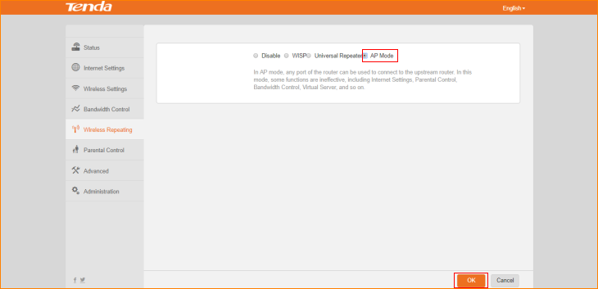
After the reboot process is complete, please use ‘tendawifi.com’ to login to the Web UI.
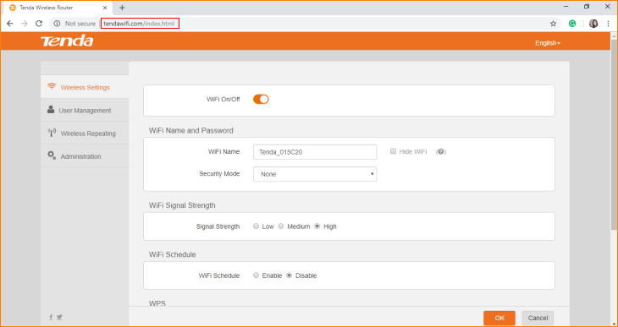In AP mode, any port of the router can be used to connect to the upstream router. In this mode, some functions are ineffective, including Internet Settings, Parental Control, Bandwidth Control, Virtual Server, and so on.

